**Web Application – Picture Gallery (Week 7)**

In this exercise, you will be implementing some functions to help fix a web application, which is a picture gallery.

**Preparation**

1. Download and unzip the **WebApplicationStartingCode.zip** file from eLearn. After unzipping the zipped file, you will find a folder called **WebApp**. Place this **WebApp** folder in your **Week7** folder.
2. Open Anaconda Prompt Window (or the Terminal Window if you are a Mac user) and navigate to the folder **WebApp** (using the **cd** command). You should see a file called “main.py” inside this folder.
3. Type the following command:

**python main.py**

1. You’ll see something like the following.

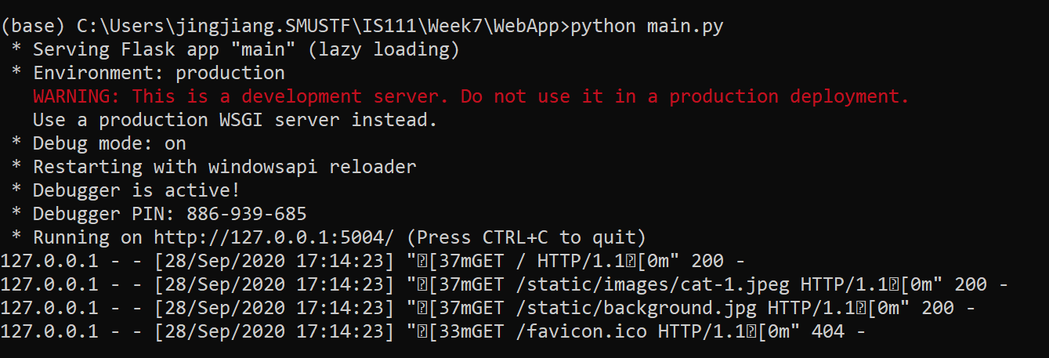

URL to copy to your browser

1. Copy the URL in your Anaconda Prompt Window (or Terminal Window) as shown above to your Web browser (e.g., Chrome). You should then see a page called “Gallery” that displays a single picture of a cat.

**Overview**

Supposedly, this application should allow you to view all the image files stored inside “WebApp/static/images”. The application also allows you to view the images separated into three groups (square images, portrait images and landscape images), and to search the images by keywords.

However, right now the application is faulty. Let’s fix the problems.

**Q1: File Extensions**

Right now, not all the image files are displayed. This is because the function is_image_file() inside util.py is implemented wrongly. Modify the function is_image_file() inside util.py so that it behaves according to the description given in util.py.

You should first implement the get_file_extension() function in util.py to help you.

After you successfully implement is_image_file(), you should see all the image files inside “WebApp/static/images” to be displayed.

Note:

* After you modify util.py, you should refresh your browser to observe the changes made to the “Gallery” application. Sometimes your browser may not display the “Gallery” page. Check your Anaconda Prompt Window to see if there has been any error running your Python code. If so, after fixing your code, you’ll need to re-run "python main.py" in the Anaconda Prompt Window.
* To debug, you can still insert print() statements in util.py, but you’ll need to remember to check the Anaconda Prompt Window for outputs of these print() statements.

**Q2: Portrait vs. Landscape**

On the page “Grouped by Orientation” page, the images are supposed to be grouped into three categories: square images (i.e., width is equal to height), portrait images (i.e., height is larger than width), and landscape images (i.e., width is larger than height). However, right now all images are categorized as square images.

Fix this problem by modify the following functions in util.py:

* get_square_image_details()
* get_portrait_image_details()
* get_landscape_image_details()

You should consider first implementing the following functions in util.py to help you:

* is_square()
* is_portrait()
* is_landscape()

After you successfully implement these functions, you should see the images corrected grouped on the “Grouped by Orientation” page.

**Q3: Keyword Search**

On the “Search” page, after the user enters a keyword such as “cat”, all those image files whose names contain the keyword as a substring should be displayed. Right now, nothing is displayed.

Fix this problem by implementing the get_matching_files() function in util.py.

**Feel free to add more images to the folder “WebApplication/static/images” to build your own gallery!**